附件2

报名二维码

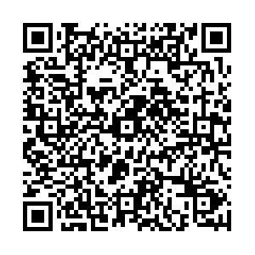

电脑端报名网址

[http://exam.renshibao.cn/xz/#/examinee/home?id=1857357451305316354](http://exam.renshibao.cn/xz/" \l "/examinee/home?id=1857357451305316354)